Great Lakes Worksheet

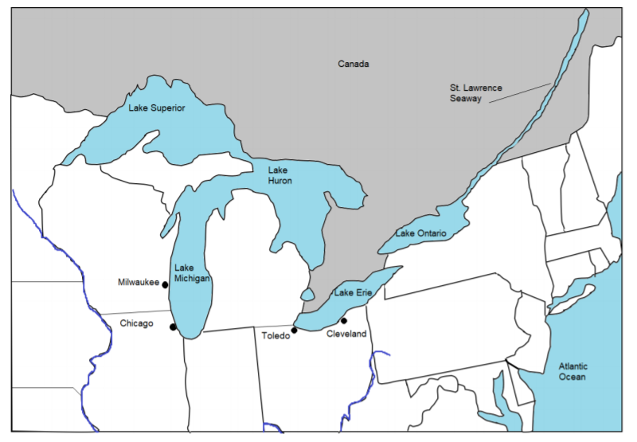

Fill in the blank with one of the following directions: N, S, E, W, NE, NW, SE, or SW.

1. Milwaukee, WI is North of Chicago, IL.
2. The St. Lawrence Seaway is east of Lake Superior.
3. Lake Erie is east of Lake Michigan.
4. The Mississippi River is west of Illinois and Wisconsin.
5. Milwaukee, WI is NW of Toledo, OH.
6. Michigan is north of Indiana and Ohio.
7. Chicago, IL is west of Lake Michigan.
8. Lake Ontario is NE of Cleveland, OH.
9. Chicago, IL is west of Toledo, OH.
10. Lake Huron is SE of Lake Superior.